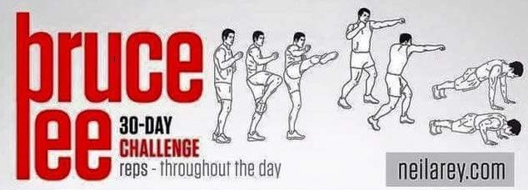
Day 1  10 Kicks  10 Punches  5 Push-ups | Day 2  25 Kicks  25 Punches  5 Push-ups | Day 3  15 Kicks  15 Punches  5 Push-ups | Day 4  5 Slow Kicks  5 Slow Punches | Day 5  35 Kicks  35 Punches  10 Push-ups
Day 6  45 Kicks  45 Punches  10 Push-ups | Day 7  50 Kicks  50 Punches  10 Push-ups | Day 8  5 Slow Kicks  5 Slow Punches | Day 9  55 Kicks  55 Punches  15 Push-ups | Day 10  60 Kicks  60 Punches  15 Push-ups
Day 11  75 Kicks  75 Punches  15 Push-ups | Day 12  5 Slow Kicks  5 Slow Punches | Day 13  85 Kicks  85Punches  20 Push-ups | Day 14  90 Kicks  90 Punches  20 Push-ups | Day 15  100 Kicks  100 Punches  20 Push-ups
Day 16  5 Slow Kicks  5 Slow  Punches | Day 17  105 Kicks  105 Punches  20 Push-ups | Day 18  120 Kicks  120 Punches  20 Push-ups | Day 19  130 Kicks  130 Punches  20 Push-ups | Day 20  5 Slow Kicks  5 Slow Punches
Day 21  140 Kicks  140 Punches  25 Push-ups | Day 22  150 Kicks  150 Punches  25 Push-ups | Day 23  160 Kicks  160 Punches  25 Push-ups | Day 24  5 Slow Kicks  5 Slow Punches | Day 25  175 Kicks  175 Punches  30 Push-ups
Day 26  180 Kicks  180 Punches  30 Push-ups | Day 27  190 Kicks  190 Punches  30 Push-ups | Day 28  5 Slow Kicks  5 Slow Punches | Day 29  200 Kicks  200 Punches  30 Push-ups | Day 30  250 Kicks  250 Punches  30 Push-ups

