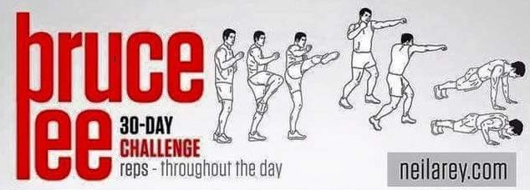
Day 1  40 Kicks  40 Punches  10 Push-ups | Day 2  50 Kicks  50 Punches  10 Push-ups | Day 3  60 Kicks  60 Punches  10 Push-ups | Day 4  10 Slow Kicks  10 Slow Punches | Day 5  70 Kicks  70 Punches  20 Push-ups
Day 6  90 Kicks  90 Punches  20 Push-ups | Day 7  100 Kicks  100 Punches  20 Push-ups | Day 8  10 Slow Kicks  10 Slow Punches | Day 9  110 Kicks  110 Punches  30 Push-ups | Day 10  130 Kicks  130 Punches  30 Push-ups
Day 11  150 Kicks  150 Punches  30 Push-ups | Day 12  10 Slow Kicks  10 Slow Punches | Day 13  170 Kicks  170 Punches  40 Push-ups | Day 14  180 Kicks  180 Punches  40 Push-ups | Day 15  200 Kicks  200 Punches  40 Push-ups
Day 16  10 Slow Kicks  10 Slow  Punches | Day 17  220 Kicks  220 Punches  45 Push-ups | Day 18  240 Kicks  240 Punches  45 Push-ups | Day 19  260 Kicks  260 Punches  45 Push-ups | Day 20  10 Slow Kicks  10 Slow Punches
Day 21  280 Kicks  280 Punches  50 Push-ups | Day 22  300 Kicks  300 Punches  50 Push-ups | Day 23  320 Kicks  320 Punches  50 Push-ups | Day 24  10 Slow Kicks  10 Slow Punches | Day 25  350 Kicks  350 Punches  55 Push-ups
Day 26  360 Kicks  360 Punches  55 Push-ups | Day 27  370 Kicks  370 Punches  55 Push-ups | Day 28  10 Slow Kicks  10 Slow Punches | Day 29  400 Kicks  400 Punches  60 Push-ups | Day 30  500 Kicks  500 Punches  60 Push-ups

